# User Manual

## Introduction

Library Path Search System (LPSS) is a system that can help you find the shortest path to fetch those books you want in the library. For a Junior Librarian, it will be very practical to reduce the work of returning books back to the shelves. This manual is used for general user and staffs of the library.

## Authority

C:\Users\Sidney\Desktop\UserMaunal\NOUSEFORGENERALUSER.png

As you can see this is main navigation bar of the website. Different types of people have different authorities to access those pages.

If you click on the page without authority, there will a warning.

|  |  |  |  |  |  |
| --- | --- | --- | --- | --- | --- |
| Pages | General user | Junior Librarian | Senior Librarian | Database Administer | Curator |
| People | No | YES | YES | YES | YES |
| Books | No | No | YES | YES | YES |
| Maps | No | No | No | YES | YES |
| Others | YES | YES | YES | YES | YES |

$$Table 1: Authority table$$

## Manage Personal Information

### Personal Webpage Introduction

Click ‘Personal’ on the main navigation bar, this will lead you to the personal page.

In this web, you can **change password**, **view and modify favorite list**, **view borrowed list and to-do list**.

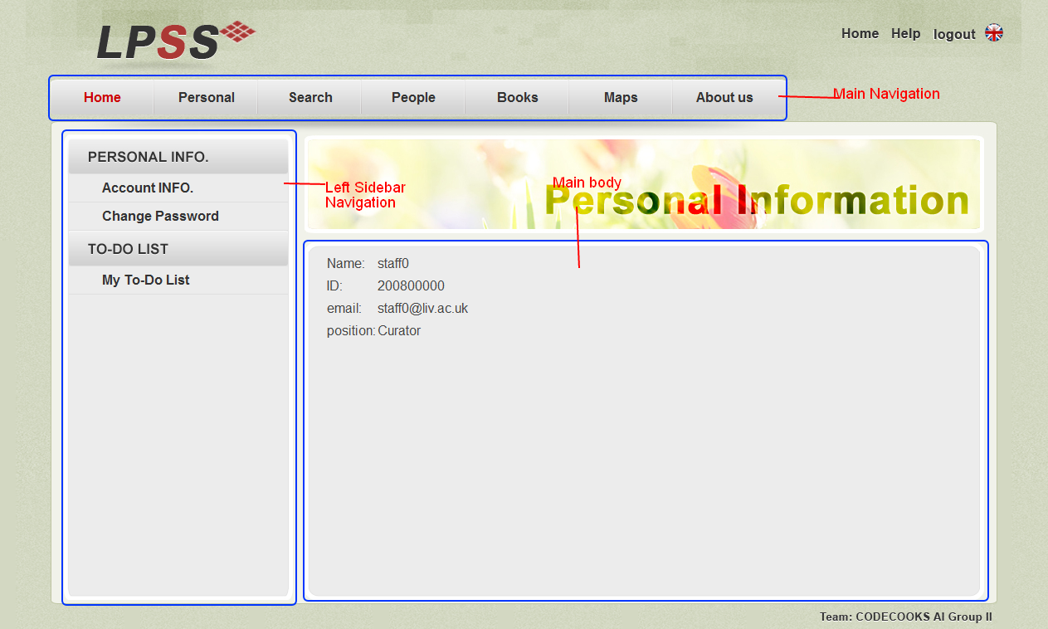

$$Figure 2:Personal page$$

The left sidebar is a little different between general user and staffs.

|  |  |
| --- | --- |
| General User | Staff |
| C:\Users\Sidney\Desktop\UserMaunal\GeneralUserNavigation.png | C:\Users\Sidney\Desktop\UserMaunal\StaffNavigation.png |

|  |  |
| --- | --- |
| If you are a general user, you can do | If you are a staff, you can do |
| 1. View personal information 2. Change password 3. View Borrowed list 4. View favorite list | 1. View personal information 2. Change password 3. View and modify to-do-list |

$$Table 3:Personal Operation Comperation Table$$

**Notice**: Modify favorite list in not in this page, the function is on the search for shortest path section.

## Search for shortest path

### Search Webpage Introduction

Click ‘Search’ on the main navigation bar, this will lead you to the Search page. On this page a user could **search for a book** and get the **shortest path** of those books that you want.

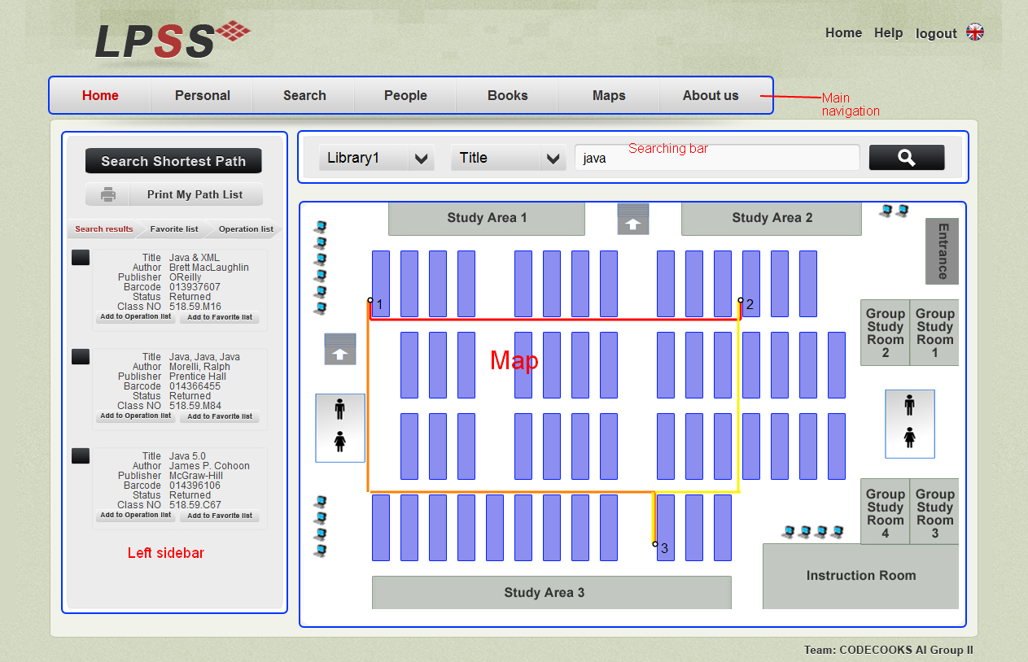

$$Figure 3.1: Map page$$

Here is a searching Bar which could be used to search for books in library:



$$Figure 3.2: Searching bar in search page$$

**Search for books steps:**

1. Choose the library: The library name that your books would be.
2. Choose search category: This could be book title, author or barcode.
3. Enter the key word: Not case sensitive

Simple click on the search icon on the right, the result will be displayed at the left of the web page.

**Get shortest path**

Just simple add the book to operation list. Then the path will be displayed on the map area.

**Display**

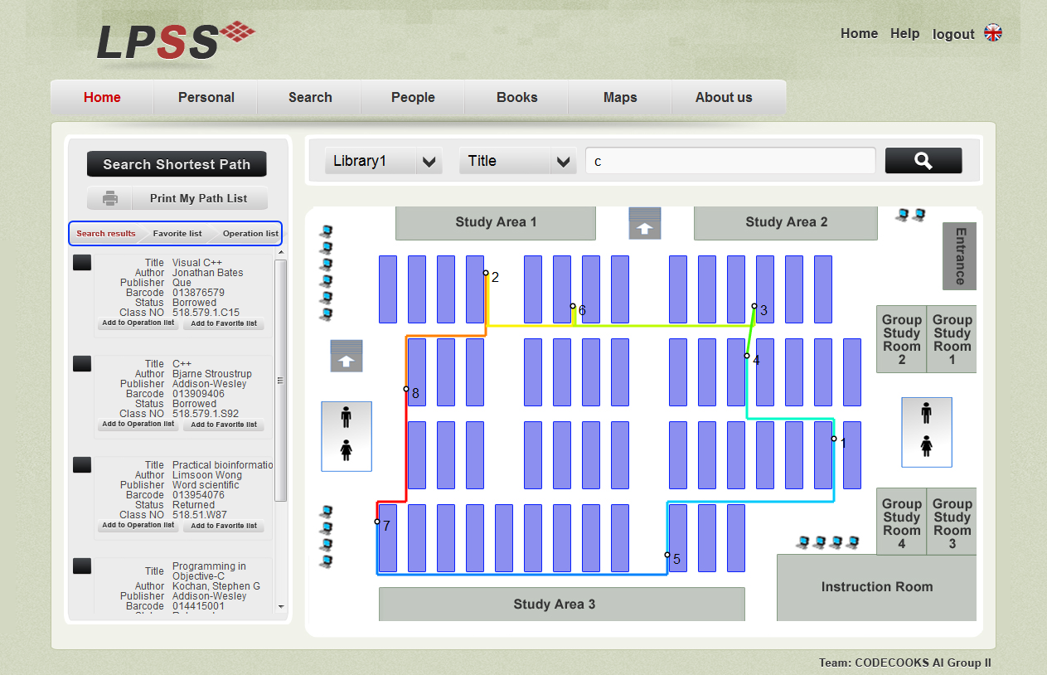

$$Figure 3.3:Tabs in left sidebar in search page$$

Click on the tabs to see the search result, favorite list or operation list.

In the favorite list, the book could be modified like add, drop or add to operation list.

The paths between each two books are in different colors which are easily distinguished.

## Staff Management

All the members including general user and staffs can be viewed by every staff, but only the curator could

### People Webpage Introduction

Click ‘People’ on the main navigation bar, this will lead you to the staff management page. In this web page a manager could **view all users** and **manage staff**.

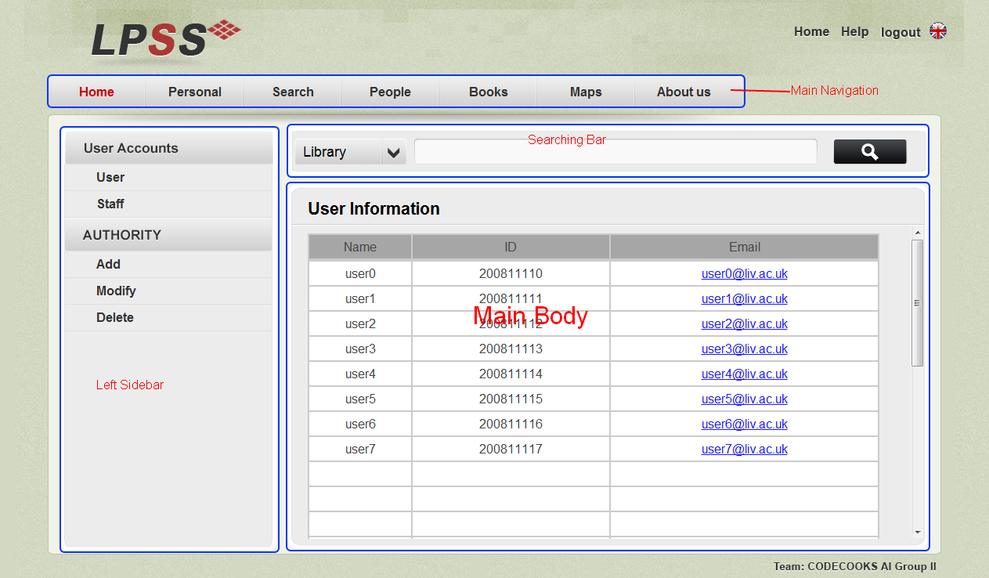

$$Figure 4.1:People page$$

There is little different between curator and other staff on left sidebar navigation.

|  |  |
| --- | --- |
| Curator | Other staff |
| C:\Users\Sidney\Desktop\UserMaunal\CuratorPeople.png |  |

So only the curator has the authority to manage people.

All the staff basic information could be viewed by other staff.

### Staff Management

There are three type operations that could be used to modify staff: **add**, **modify** and **delete**.

#### Add Staff

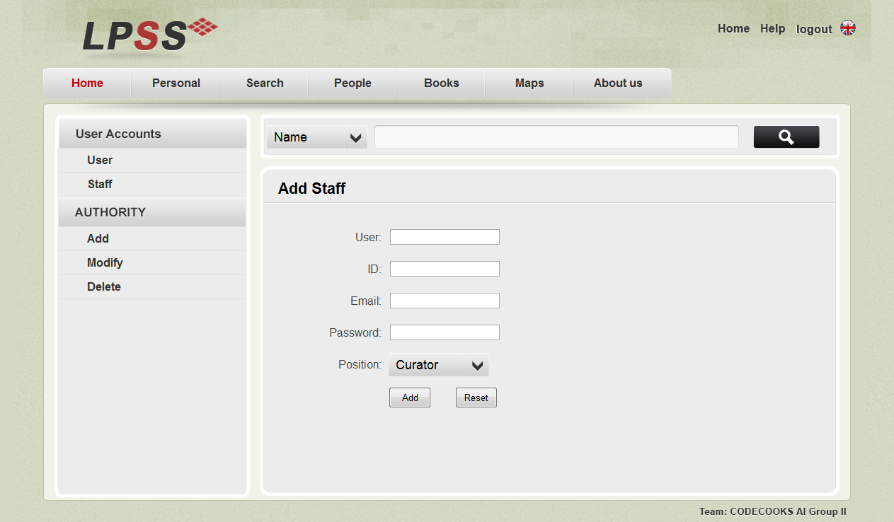

$$Figure 5.1:Screen shot of add staff$$

If and only if the conditions bellow are satisfied the staff could be add:

1. User name could not be the same with other staff
2. User ID could not be same with other staff, ID should be numbers.

The reset button is to clean everything entered.

#### Modify Staff

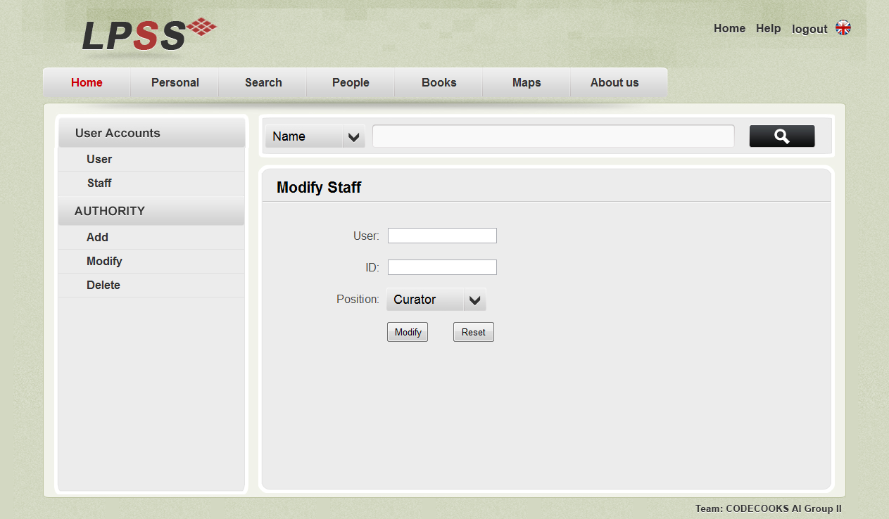

$$Figure 5.2:Modfy staff fucntion screen shot$$

If and only if the following conditions are satisfied, then the staff’s position could be changed.

1. The user name entered should exist.
2. The ID of the user must be the correct

The reset button is to clean everything entered.

#### Delete Staff

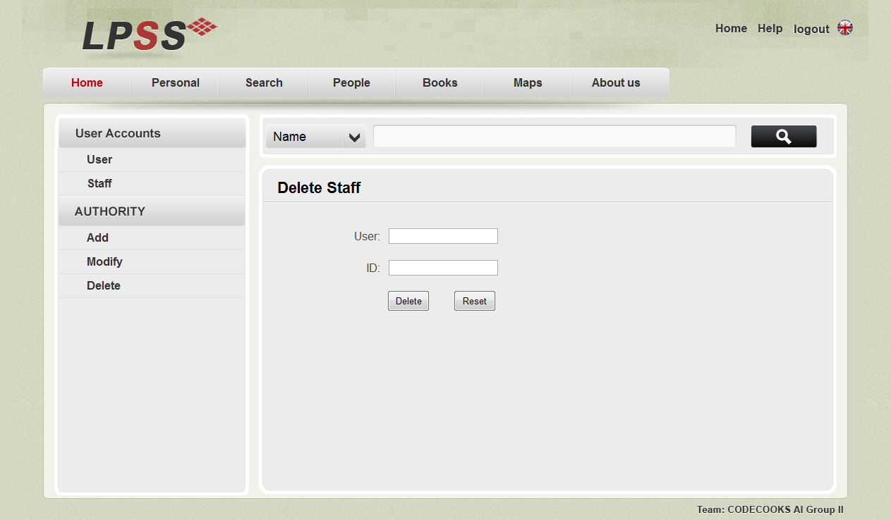

$$Figure 5.3:Delete staff screen shot$$

If and only if the following conditions are satisfied, then the staff could be deleted.

1. The user name entered should exist.
2. The ID of the user must be the correct

The reset button is to clean everything entered.

## Add Book

Only Senior Librarian, Database Administer and curator could add a book to the database.

### Book Webpage Introduction

Click ‘Books’ on the main navigation bar, this will lead you to the book adding page. Senior Librarian can use this page to **add books** to the database.

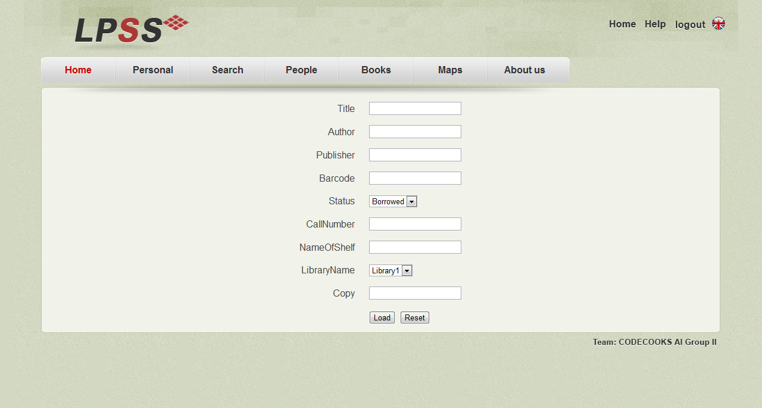

$$Figure 6.1:Screen shot of book page$$

Senior Librarian can use this page to add books to the database, if and only if the barcode and callNumber of the book are both not the same with other books and the copy of the book is integer, then the book could be added.

## Edit Map

Only the curator and database administer could edit a map. This function is not fully implemented that the map cannot be stored to the database.

### Map Webpage Introduction

Click ‘Maps’ on the main navigation bar, this will lead you to the map edit page. Database administer can use this page to **edit maps** of the database.

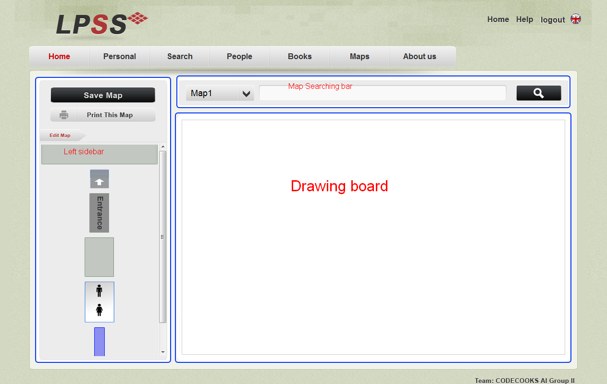

$$Figure 7.1:Screen shot of map page$$

### Edit Map

There is some stuff that a library may have in the left sidebar.

**Add stuff to the map**: Simple drag the stuff to the map.

**Draw map**: In the main body of map page, hold the left button of mouse and move.

**Notice:** As this function in implemented using HTML5, it can only be used on the browser which supports HTML5 such as chrome. The map cannot be saved to the database.

## About Us

Click ‘About us’ on the main navigation bar, this will lead you to webpage which contains information about us. If you wish to contact us, there is some contact information.

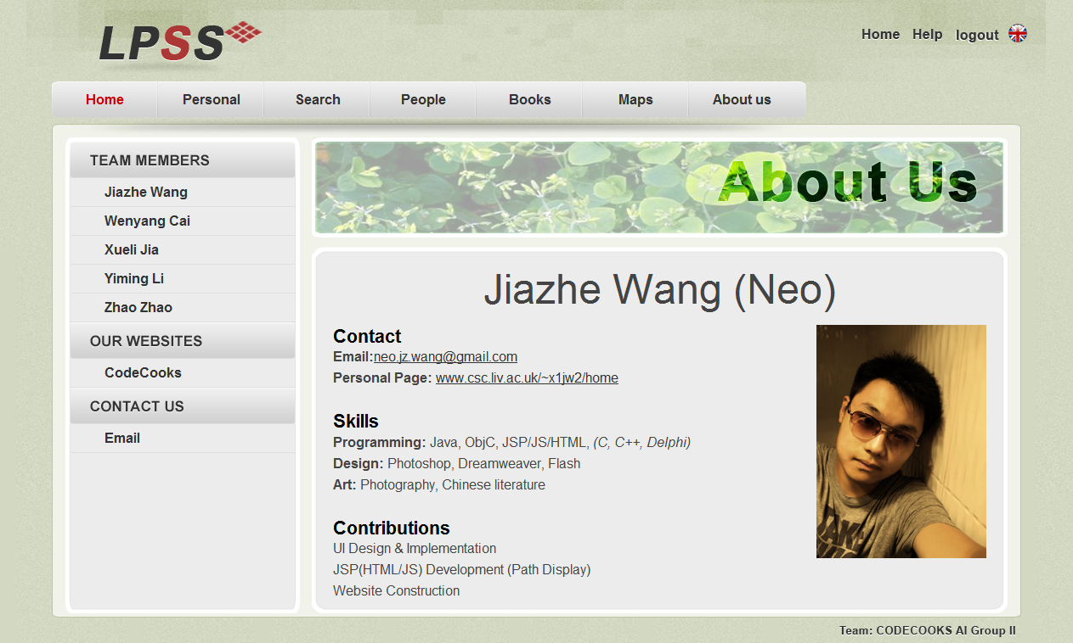

$$Figure 8:Screen shot of Abou us page$$

## Section not implemented:

**Search for staff**



$Figure 8.1:Search bar in people page$

This searching bar is used for searching for staffs and users in the library.

**Search for library map**



$$Figure 8.2:Search bar in map page$$

This searching bar is used to search for map of a particular library.

The functions above are not implemented. Please wait for high version of the system and sorry about the inconvenience.